**TECHNICAL UNIVERSITY OF CLUJ-NAPOCA**

**DEPARTMENT OF DESIGN ENGINEERING AND ROBOTICS**

**MASTER'S DEGREE IN ROBOTICS**

**RESEARCH PROJECT**

**STUDENT**

**CĂLIAN ALEXANDRU - ȘTEFAN**

**SERIES OF STUDY 2023-2025**

**TECHNICAL UNIVERSITY OF CLUJ-NAPOCA**

**DEPARTMENT OF DESIGN ENGINEERING AND ROBOTICS**

**MASTER'S DEGREE IN ROBOTICS**

**CĂLIAN ALEXANDRU - ȘTEFAN**

**DESIGN AND IMPLEMENTATION OF A ROBOTIC SYSTEM FOR HIGH PRECISION GLASS FACADE CLEANING**

**SCIENTIFIC COORDINATOR**

Prof. Dr. Ing. Stelian Brad

1ST SEMESTER

**PROJECT PRESENTATION**

**1. VISION**

This project has in mind the design and implementation of a robotic system for high precision glass façade cleaning. It will mainly consist of the initial documentation phase where I will study the working principle of said system while also consulting the current stage of development.

Following this, I want to study and take into consideration every component that is involved, from the mechanical structure, to the technologies used and the train of thought in utilizing the most effective and efficient software. After this I will need to do the required calculation with regards to the physical mechanism of the robot and also the programming part of it. A physical or simulated design of the robotic system will need to also be created so that in the final phase I can readjust and correct existing problems and eventually improve the existing solution.

**2. OBJECTIVES AND ACTIVITIES PLANNED FOR SEMESTER 1**

For the first semester I plan to accustom myself with the current subject, study the current solutions that have been or are currently in development, and try to create a personal solution that incorporates the best solutions that have been considered or approached in the already existing ones.

**3. OBJECTIVES AND ACTIVITIES PLANNED FOR SEMESTER 2**

For the second semester I want to start doing the calculations necesary in creating the phsical mechanism and structure of the robotic system while also taking into consideration the software and programming solutions that need to be developed.

**4. OBJECTIVES AND ACTIVITIES PLANNED FOR SEMESTER 3**

For the third semester I plan on recreating the robot in a physical representation or in a simulated environment.

**5. OBJECTIVES AND ACTIVITIES PLANNED FOR SEMESTER 4**

For the last semester I want to revisit the work realised on the course of the previous semesters in hope that i can readjust or fix certain errors or even try to improve the current stage of the project.

**DOCUMENTATION ON THE RESEARCH TOPIC**

1. **Introduction in the project theme**

Before diving into the project i would like to make a introduction to the current state of development regarding this theme while also emphasising the importance of said developments in current industry, and in the near future.

In our current time period glass façade cleaning is very important in maintaining a building simply because of the environment elements that degrade the glass over time if not cleaned diligently.

Dirt, sand and bird residue are the most common elements that stain the glass of the façades deteriorating it over time which is the most important hazard when we talk about glass maintenance. Periodical cleaning is also important in keeping up the appearance of a building, especially if we are talking about a skyscraper or more likely a company building.

We need to take into consideration that a good part of the current population is linking the way a building is presented itself, to the direct representation of the diligence and responsibility of the people that maintain it.

When we talk about glass façade cleaning, we talk about two different solutions:

- manual labor cleaning

- semi-automatic/fully automated cleaning

* 1. **Manual labor cleaning**

Manual glass façade cleaning is the most common one out of the two, simply because recruiting more human working force is easier and less costly than actually developing a robotic system for it, not to forget about the maintaining cost that is even cheaper than maintaining the robot.

These are the most important advantages that “classic” façade cleaning brings, but also the only ones because outside of these we got only disadvantages, especially when talking about the risks that need to be taken into the equation.



Figure 1.2 Scaffold facade glass cleaning

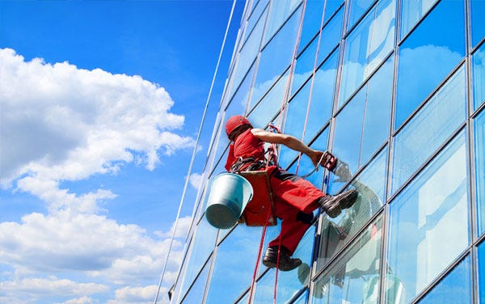

Figure 1.1 Rope scaffolding facade cleaning

1. Personnel training

The first disadvantage that we need to take into consideration is the cost of training the workers because is one of the most crucial factors when trying to improve the quality of the service while also diminishing the risk of injury at the working place. A considerate amount of time will be taken into correctly instructing the workers to utilize the scaffolding tools in a safe environment, making routine checks for the maintenance of the tools, using proper techniques in ensuring their own safety while also doing their job efficiently.

1. Working at height

Cleaning high buildings and skyscrapers present a higher risk than cleaning at a smaller scale simply because of the height, which poses the most common cause of workplace injuries and fatalities in the

United Kingdoms as told in an article posted on the page of the insurance company Markel.

Data from Reporting of Injuries, Diseases and Dangerous Occurrences Regulations known as RIDDOR, shows that this practice was to blame for 8% of all non – fatal injuries at work during the time period of 2021-2022, while 29 workers lost their lives while falling from height in the same time period.

Even if the Work at Height Regulations that were revisited in 2005, state that window cleaners may work from height only when a different approach is not possible, most of the situations call for scaffolding the building.

1. Injuries at the working place

Because of the limited space in which a worker has to clean the façade, the risk of injury is higher than most of the working environments. Window cleaners are prone to RSI or repetitive strain injury that can develop if you repeatedly use one part of your body in a certain way, in this case repeatedly using the arms and shoulders in reaching, pulling and pushing motions.

The right use of protective equipment while also taking regular breaks will lower the risk of contracting this kind of injuries.

1. Property damage

Because the job of a window cleaner brings you into contact with members of the public and their property, no matter how careful or trained you are, there is always a risk of inadvertently damaging someone’s property during work.

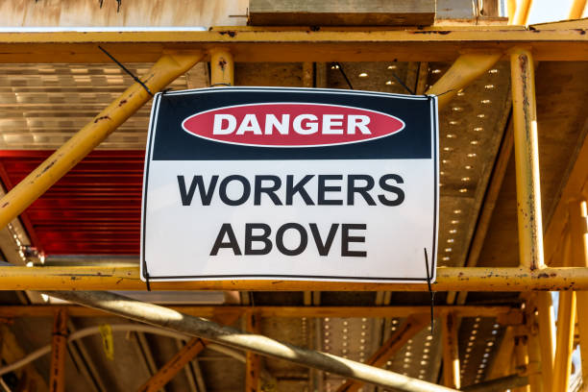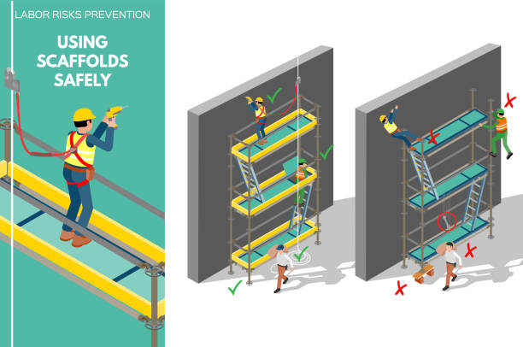

Figure 1.4 Work hazard warning

Figure 1.3 Scaffolding safety instructions

* 1. **Robotized cleaning**

All these risks and disadvantages presented in the previous pages, will directly influence the quality of the service, while also compromising on the efficiency regarding the time needed to complete the cleaning and the profit.

This is why the requirement for clean and safe working conditions has driven the advancement of robotic innovations that are used in façade glass cleaning.

The evident advantage is the lack of personnel involved in the cleaning of the façade glass. Depending on the cleaning solution adopted in developing the robot, there is needed only a single person that is tasked with controlling and adjusting the robot’s path in the case of semi-automated robots, or none at all if we are talking about fully automated robotic systems.

Another considerable advantage is the fact that robotized solutions are capable of reaching location on the façade that were proven unreachable in the case of manual cleaning. This feat was achieved by removing the suspended gondolas, wires and ropes that were mandatory in traditional façade glass cleaning, instead using different types of locomotion and adhesion mechanisms that facilitate the movement of the robot on the glass.

The current research interest in developing various automated wall-climbing robots capable on maneuvering on vertical or inclined surfaces have increased the productivity and efficiency in cleaning operations, that have determined a considerable rise in the production of said robots.

While this advancement is putting in danger the considerable amount of classic façade glass cleaning businesses that have flourished over the years, it is also considered an immense improvement in the work safety area, while also pushing existing businesses to adopt the automatization of the working environment.

Even if the cost of said advancements are more considerable than the cost of the working force in the case of manual cleaning, we need to take into consideration that a automatized solution is more profitable on the long term, because it eliminates the additional costs deducted from the training of personnel, while also being more time efficient and risk free.

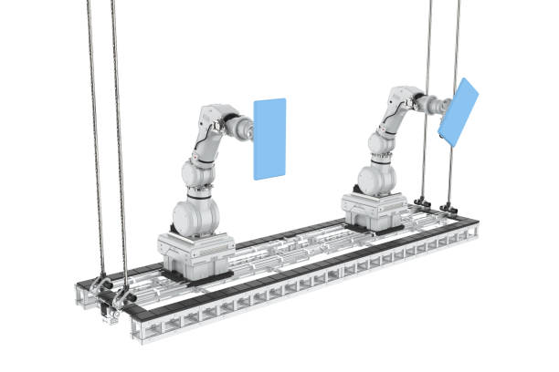

Figure 1.6 Another example of a robotized solution



Figure 1.5 Example of robotized solution

* + 1. **Semi – automated VS fully automated robotized solutions**

As we discussed before, when talking about robotized solutions we have two candidates. Each of them is proposing similar solutions in cleaning the glass of façades, the main difference being in technologies used, mechanical structure and most importantly on the degree of automatization.

Semi-automated solutions – are usually controlled by a worker from a close distance, using a navigation device in order to control the movements of the robot. The worker in cause is usually less than 20 meters away, in a mobile scaffold at the same attitude as the robot, on the roof of the building, or in the said building, while the movements are transmitted to the robot wirelessly. The limited range of communication between the robot and the worker explains why he has to be close to the robot.

The robot is tethered by a security chord to the building or to the scaffold in which the worker controls it for security measures, in case the robot’s adhesion mechanism fails and it detaches from the façade.

Fully automated solutions – on the other hand, do not require any additional assistance from a human operator, while working. In the same manner as the semi – automated variants, it is tethered to the building using ropes, wires or scaffolds. They are equipped with sensors and cameras that collect information of the surrounding in order to create 3D maps of the working environment, while also calculating it’s every movement for the sake of a high efficiency in cleaning.

The behavior of the robot can be tracked through a GUI – graphical user interface, by an operator who can make decisions depending on the progress of the robot or if a problem arises.

If we are talking about either semi-automated or fully automated robotized solution, each and one of them have some advantages and disadvantages, coming down at the cost of manufacturing, cost of implementing the solution while also considering the possibility of said implementation in a real-life scenario, and also the cost of maintenance, in addition to the facts underlined in the lines above.

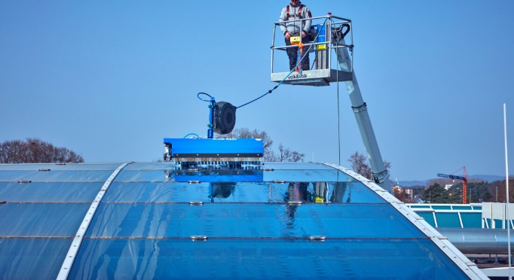

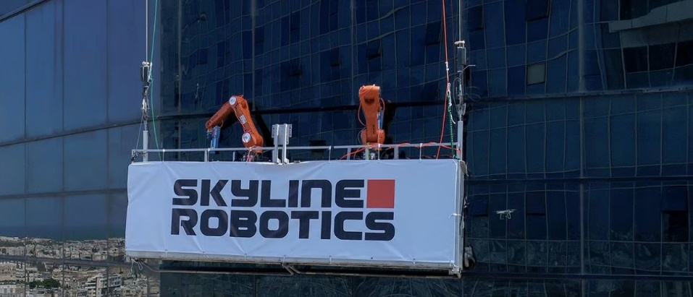

Figure 1.7 Semi-automated robot. hyCleaner glassROBOT pro

Figure 1.8 Fully automated robot. Ozmo developed by Skyline Robotics. KUKA

**RESULTS FROM 1ST SEMESTER**

1. **Process of Thought**

The first step in this project would be to underline the main components that are taken into consideration when designing and implementing the robotized solution for cleaning glass façade.

While taking into consideration the notions discussed in the first chapter, we have the following components:

1. The mechanical structure of the robot
2. The technologies used in automating the cleaning process
3. The total costs of designing and implementing of the solution

With these three factors in mind, we can undertand them better by anylizing currently developed solutions over the world, as a point of start in our study.

* 1. **Semi – automated robots**

One such solution for semi-automated robots is produced by hyCLEANER, in Germany.

As explained in the previous chapter, this is the kind of robot that is controlled remotely by an operator that has to be near the robot. A cord thethers the robot to the building or a near structure, while the worker is controlling the path taken.

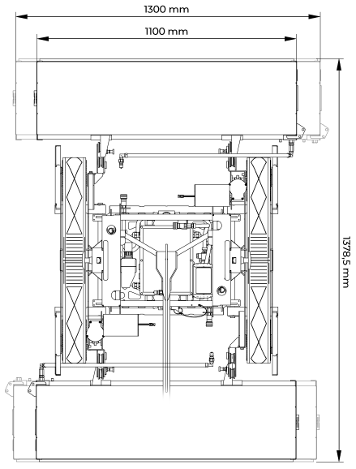

Figure 2.1 Dimensiunile robotului de la hyCLEANER



Figure 2.2 Vedere a mecanismului robotului

As mentioned by the producer, the cleaner is ECO- friendly because of the cleaning solution that involves a reduced amount of water, aproximately 8 liters per minute, which consists 20 times less that conventional high – pressure cleaning systems.

The system is easy to control and easy to learn making the training phase less time consuming than with other products. The flexibility of the product comes from the fact that it can be used on different types of glass while also being easy to disassemble and transport.

The producer mentions the fact that the robot can clean up to 2400 square meters per hour.

After further inspections, we deduce that the cleaning solution is composed of a cilindrical roll with fine bristles that rotates, while being constantly lubricated with water.

Te moving mechanism is composed from two rows of tracks, similar with the solid chain tracks used for tanks, denoting the fact that this robot is not able to move on surfaces that are stepper than 30 degrees, because of the risk of falling.

Further modification could be added to the robot, by adding a adhesion mecanism that could allow it to move on the facade of buildings. Outside of this the robot is equipped with sensors used for edge detection, so the robot does not fall off the roofs.

* 1. **Fully automated robots**

In the case of fully automated robots we have a variant that is very similar to the semi automated solutions presented before, the difference being in the fact that it does not need to be operated by a human. One of such robots is the kite robot developed by Kite Robotics, which consists of a central cleaning element, a robot equipped with a identical cleaning solution as the one that hyCLEANER proposes.

The robot is attached to the four corners of the facade by four light-weight wires which navigates by specially developed winches, on the corners.

By changing the wire lengths in a coordinated way, the robot is able to move itself and clea the facade in vertical adjacent tracks.

Once the robot is connected, it calibrates itself and automatically starts cleaning in such a manner that after it finished cleaning, the robot returns to its starting position, where the system can be easily disconnected again. The robot is proficient in cleaning surfaces that have up to 20 cm depth, but nothing more than that.

The flexibility of the robot comes from his automated cleaning program that is a pre-programmed route, while also being able to be controlled remotely, becoming a semi- automated cleaning robot.

The maintenance of the robot is optimized and calculated from a database that is collecting in real time informations regarding the robot running time and motor output that is collected from the sensors equipped on it.

The producer mentions that the cleaning robot solution is capable of covering 300 square meters of glass per hour.

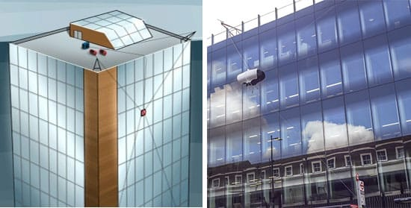

Figure 2.3 The kite robot working concept

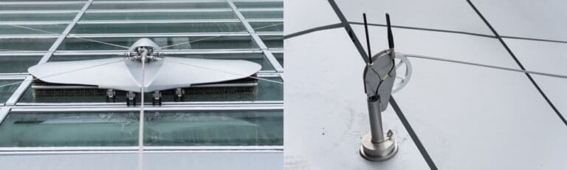

Figure 2.4 The tethering solution of the robot

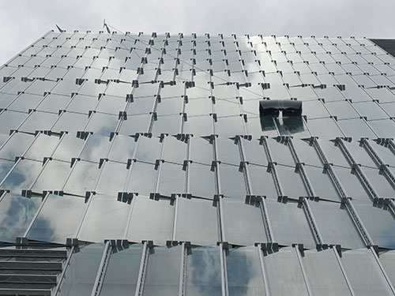

Figure 2.5 The kite robot in action

Another solution proposed in the case of automated robots is a very innovative one simply because it is the only functional robotization, currently on the market.

It is about the project Ozmo: Kr Agilus, developed by Skyline Robotics, a special project developed by KUKA that is focused on developing and upgrading existing solution in the business of facade cleaning.

The uniqueness of the solution proposed by Skyline Robotics comes from the fact that they use robotic arms that clean the facade glass through the use of cleaning brushes attached as end – effectors.

The solution is composed of two of these robots that are fixed on a scaffold which moves with the robot. Basically it is a system that combines KUKA’s Kr Argilus robots with a computerized vision system, artificial intelligence and machine learning technologies.

In order to provide the power and water needed in order to execute the cleaning tasks, Ozmo is designed to fit into a building’s existing building maintenance unit infrastructure, gathering the power and water supply from the building itself.

Within the scaffold basket, a table houses several types of sensors and computers used to communicate with the robot and its other utilities.

The robot arm is equipped with a Lidar camera that uses class 1 lasers for imaging, a category of lasers safe for humans. The system is ready to work once the table its fixed on the mobile scaffold.

The robot arm is continuously communicating with the Lidar camera that collects surrounding images and creates a 3D map of the working area. In combination with other sensors, these technologies are used to continually optimize the path planning at a rate of about 200 times per second, while automating the robot’s descent down the glass of the facade.

As mentioned before, the robotic arm used in this solution is the KUKA Kr Agilus, a 6 axis robot that is built to sustain harsh environments, while being totally waterproof.

Skyline has developed an algorithm that allows for feedback for force control and other variables that give the possibility to control how much pressure the robot applies to the glass, through the use of force torque sensors, placed on the cleaning brush device.

Through the use of artificial intelligence, the robot can stabilize in real time and recalculate the cleaning path, while taking into consideration different environmental hazards that can modify it, like the wind blowing or peculiarities of the mobile scaffold kinematics while ascending and descending.

The continous path adjustment is detrimental in figuring out different cleaning paths that need to be approached when the scaffold of the building is at a certain angle or presents different obstacles.

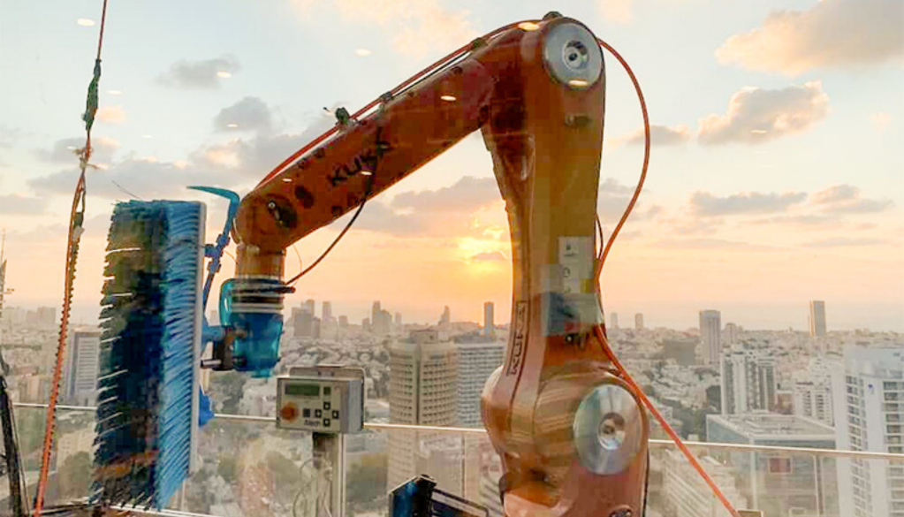

Figure 2.6 Cleaning process as seen from the inside of the building

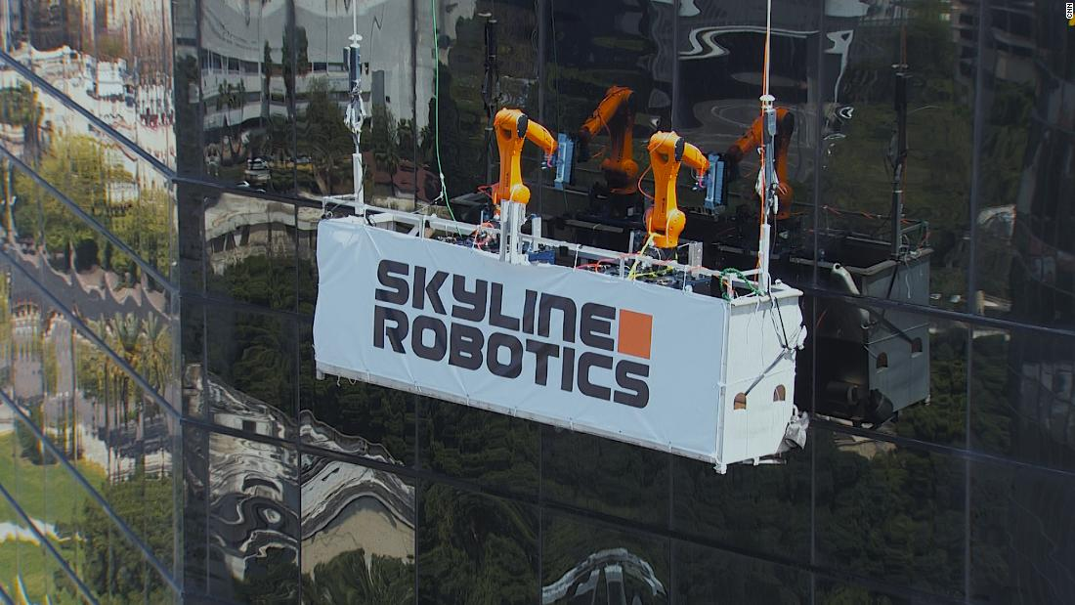

Figure 2.7 The Ozmo system in action. Automated facade glass cleaning

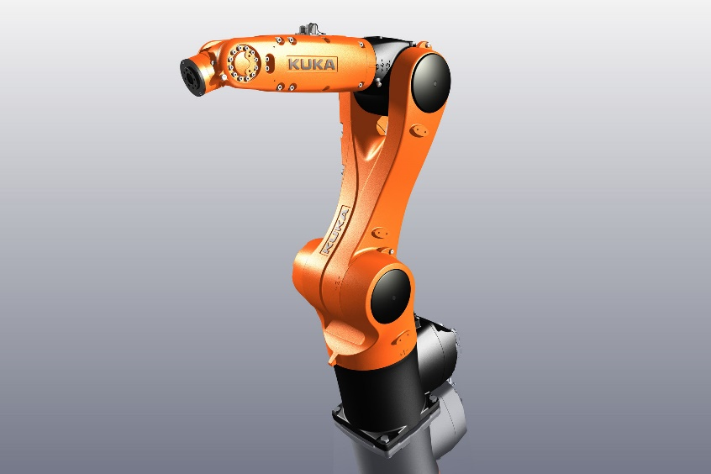

Figure 2.8 KUKA KR Agilus 6-axis robotic arm

1. **Considering the current solutions**

After taking into consideration the current development of the facade cleaning robots and other sources, we need to adress the solution for each component that is part of the final robotized assembly.

With this being said, we have the following:

* 1. Locomotion mechanisms

The optimal movement of the robots is secured by the locomotion mechanism of the said robot, or of the container/compartment where the robot is secured. As such, the most common locomotion techniques are mostly similar to the ground mobile robots. The track like structure composed of multiple wheels that are engaged by a caterpillar track can represent a good solution, especially if the track structure is fabricated out of a soft material that facilitates the movement on glass, without scratching it. This way silicone enveloped wheels and a silicone caterpillar track can represent a good solution.

Translation and sliding frames or guide rails can also represent a solution for more precise movement, while also eliminating the need for a adhesion mechanism that needs to keep the robot in contact with the glass while moving.

The problem with this kind of solution is the aditional preparation that needs to be made to the building that needs to be cleaned. Such installment needs proper time and is very time consuming and costly when talking about the need to maintain it.

The best solution would be a much complex one that would involve the concept of nested reconfigurable robots. The concept aims to develop robots that can be applied to autonomous facade cleaning on buildings with various types of architecture, such as rounded glass surface, spherical surface, or different types of structures that can limit the movement of the robot or restrict it at all, like beams or reams. Because the typical facade cleaning robots work on flat glass panels that are connected by frames, they need to clean the windows according to the frame shape.

The concept achieves autonomous cleaning according to window shapes, while using multiple modular multilegged robots capable of reconfiguring their morphology based on window shapes, which is executed by transforming their own module or connecting with each other and letting the robots cooperate.

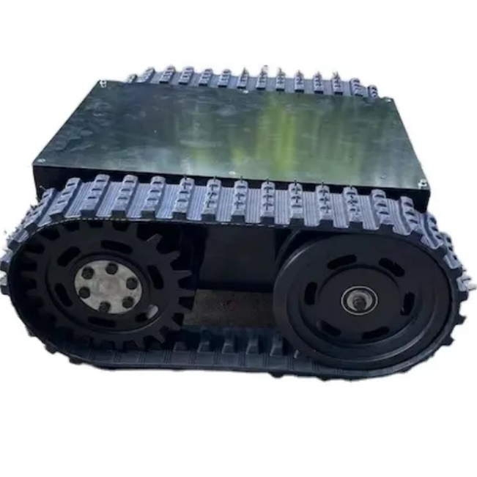

Figure 3.1 Caterpillar rail solution

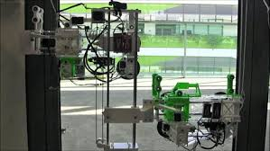

Figure 3.2 Nested Reconfigurable robots concept

* 1. Adhesion techniques

The adhesion techniques are mandatory for the robot, as without it, it is not possible to keep itself attached to the glass without additional support structures that can hinder or restrict its movement on the facade in the scope of cleaning the glass.

As such, there are a few techniques adopted in the development such as pneumatic or magnetic solutions. The magnetic solution is realised with the use of permanent magnets, electromagnets or even electro – permanent – magnets that are attached to the robot. This solution suffers from the same disadvantage as the locomotion mechanism that involves rails.

There are some less common solutions that involve electro or chemical adhesion.

Out of all of them, the pneumatic adhesion is the most used and suitable for developing facade cleaning robots, particulary with the high payload. The combination of active and passive pneumatic adhesion generated by the active vacuum of the suction cups is the real selling point of this solution.

The active vacuum is generated by a solenoid valve, an electromechanical valve that can control the airflow in a vacuum system to help create or dissipate the vacuum.

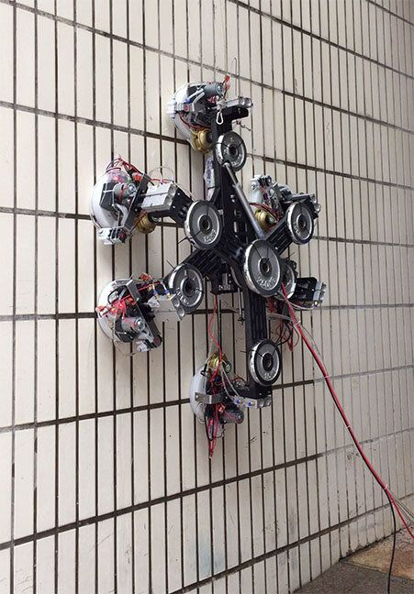

Figure 3.2 Suction cups in action for a climbing robot

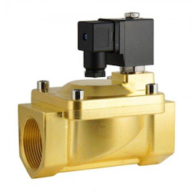

Figure 3.3 Solenoid valve

* 1. Instruments for data collection

When we talk about data collection we are talking about the way of the robot to communicate with the surrounding in order to determine the cleaning pattern it needs to follow while also making micro-adjustments constantly, and maintaining the efficiency and safety during the entire work process.

First of all we need a device for image aquisition, and for this task, the Lidar camera is the best candidate, as explained in the previous chapters. Through it we can collect very precise data regarding to the surface that needs to be cleaned and the nearby surroundings so the robot can readjust its trajectory in real time, especially if it is close to one of the building edges.

Pressure force sensors are also important for controlling the force that is applied by the robot’s cleaning mechanism, so that the glass is not scratched or cracked. This kind of sensors in combination with vacuum regulators can be used in order to maintain a consistent level of facuum by adjusting the flow of air. This is a crucial factor because in order for the robot to move on the glass, the vacuum inside the adhesion mechanism needs to be weak enough for the robot to slide freely on the facade , but strong enough in order for it to remain attached to it.

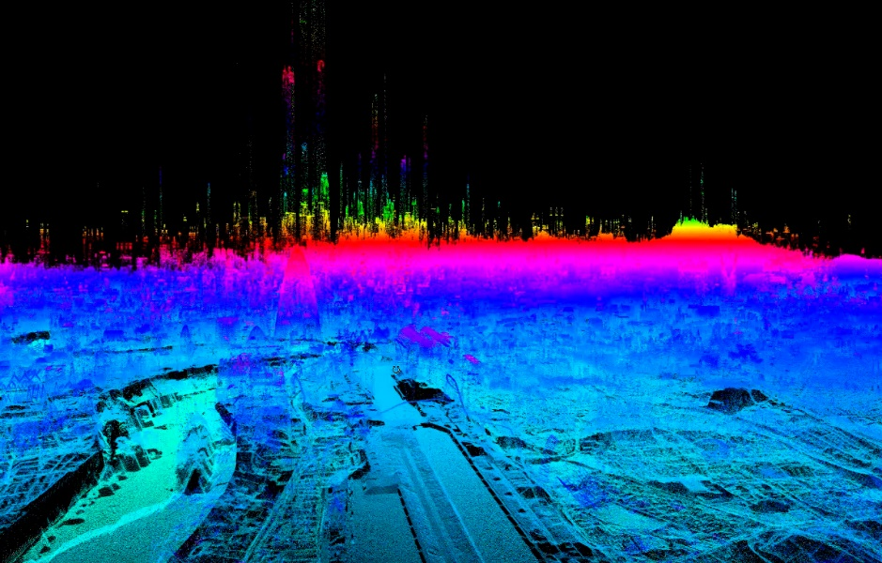

Figure 3.4 Lidar data visualisation. Depth and distance representation

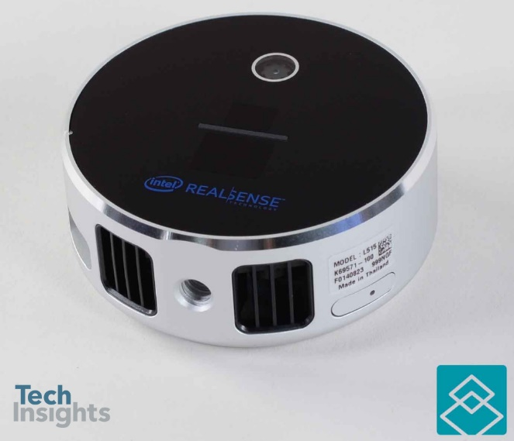

Figure 3.5 A lidar camera developed by intel

**BIBLIOGRAPHY 1ST SEMESTER**

1. „What are the risks for window cleaners” – MARKEL: https://www.markeluk.com/articles/what-are-the-risks-for-window-cleaners
2. „Modeling and Analysis of a Glass Facade Robot” – MDPI: Rizuwana Parween , Mohan Rajesh Elara , Zaki Saptari Saldi, Thomas and Madan Mohan Rayaguru
3. „Window shape estimation for glass facade cleaning robot” - https://www.glassonweb.com/article/window-shape-estimation-glass-facade-cleaning-robot
4. A novel neste reconfigrable approach for a glass facade cleaning -https://www.mdpi.com/2411-5134/2/3/18
5. „Design and development of a glass facade cleaning robot” - https://www.sciencedirect.com/science/article/abs/pii/S0094114X2100327X
6. hyCleaner glassRobot - https://hycleaner.de/en/products-glass/#section-341-19
7. The kite robot - https://www.kiterobotics.com/en/the-kite-robot/
8. „KR Agilus climbs to new heights as a window cleanre” - https://www.kuka.com/en-hu/industries/loesungsdatenbank/2022/03/skyline-robotics-fassadenreinigung-roboter
9. „Meet Ozmo” - https://www.skylinerobotics.com/meet-ozmo

2ND SEMESTER

**ADJUSTMENTS TO THE WORK PLAN**

**1. OBJECTIVES AND ACTIVITIES ADJUSTED FOR SEMESTER 2 IN RELATION TO THE INITIAL PLAN**

Here you present what you want to achieve at the end of semester 2 and what activities the project includes in order to reach the objectives

**2. ADJUSTED OBJECTIVES AND ACTIVITIES FOR SEMESTER 3 IN RELATION TO THE INITIAL PLAN**

Here you present what you want to achieve at the end of semester 3 and what activities the project includes to achieve the objectives

**3. ADJUSTED OBJECTIVES AND ACTIVITIES FOR SEMESTER 4 IN RELATION TO THE INITIAL PLAN**

Here you present what you want to achieve at the end of semester 4 and what activities the project includes to reach the objectives

**RESULTS FROM 2ND SEMESTER**

Here include as many sections as you see fit to describe the work of semester 2.

**BIBLIOGRAPHY SEMESTER 2**

Here you include the bibliographical references for semester 2.

**ANNEXES SEMESTER 2**

This section remains if you have attachments to add; otherwise, delete this section.

3RD SEMESTER

**ADJUSTMENTS TO THE WORK PLAN**

**1. ADJUSTED OBJECTIVES AND ACTIVITIES FOR SEMESTER 3 IN RELATION TO THE ORIGINAL PLAN**

Here you present what you want to achieve at the end of semester 3 and what activities the project includes in order to reach the objectives

**2. ADJUSTED OBJECTIVES AND ACTIVITIES FOR SEMESTER 4 IN RELATION TO THE INITIAL PLAN**

Here you present what you want to achieve at the end of semester 4 and what activities the project includes to achieve the objectives

**RESULRS FROM 3RD SEMESTER**

Here include as many sections as you see fit to describe the work of semester 3.

**BIBLIOGRAPHY FROM 3RD SEMESTER**

Here you include the bibliographical references for semester 3.

**ANNEXES SEMESTER 3**

This section remains if you have attachments to add; otherwise, delete this section.

4TH SEMESTER

**ADJUSTMENTS TO THE WORK PLAN**

**1. ADJUSTED OBJECTIVES AND ACTIVITIES FOR SEMESTER 4 IN RELATION TO THE ORIGINAL PLAN**

Here you present what you want to achieve at the end of semester 4 and what activities the project includes in order to reach the objectives

**4TH SEMESTER RESULTS**

Here include as many sections as you see fit to describe the work of semester 4.

**BIBLIOGRAPHY SEMESTER 4**

Here you include the bibliographical references for semester 4

**ANNEXES SEMESTER 4**

This section remains if you have attachments to add; otherwise, delete this section.